ICC Chromascan Software Installation Instructions
Table of Contents
Minimum Requirements and Process Diagram 2
Download ICC files 3
Instructions to retrieve latest regional update file 4
Upgrade from ICC v2.47 to v3.0.14 6
Clean ICC V3.0.14 Install (New User) 17
Recommended settings for each Region 30
How to Map to a Network Drive (for Akzo Network Users) 40
How to retrieve a Log File 42

For enquiries please contact the Global Colour Support Team:
Anisha Showan
anisha.showan@akzonobel.com
Tel No: +44 191 402 2722
Francesca Trobec
francesca.trobec@akzonobel.com
Tel No: +44 191 401 2583

Regional Contacts

EMEA – Lee Dixon; lee.dixon@akzonobel.com
AP – Eugene Lim; eugene.lim@akzonobel.com
AMS – Waleed Ahmed; waleed.ahmed@akzonobel.com
SAM – Larone Moreira; larone.moreira@akzonobel.com
KOR – Suhyun Kim; suhyun.kim@akzonobel.com

Minimum Requirements and Process Diagram

The minimum requirements before installing ICC V3.0.14 are as follows:
- W7, 8 or 10 computer
- Admin Rights
- Internet access preferred
- Software User Agreement available online
Note – A unique GUID identification number is required for each install of ICC V3.0.14. The ICC V3.0.14 cannot be installed without a valid GUID number. Please contact the global colour team to request a GUID number/numbers. Please inform us if more than one computer is being used and if they have internet access.
- Every computer requires a GUID. E.g. 2 computers in one location will require 2 separate GUID’s.
Process Diagram:

Download ICC files

To download the ICC install files and/or the regional specific update files, please go to the ICC Download Extranet site: http://www.international-pc.com/color/icc.aspx
To download a file, simply right select the required file name and select ‘Save target as’
e.g.
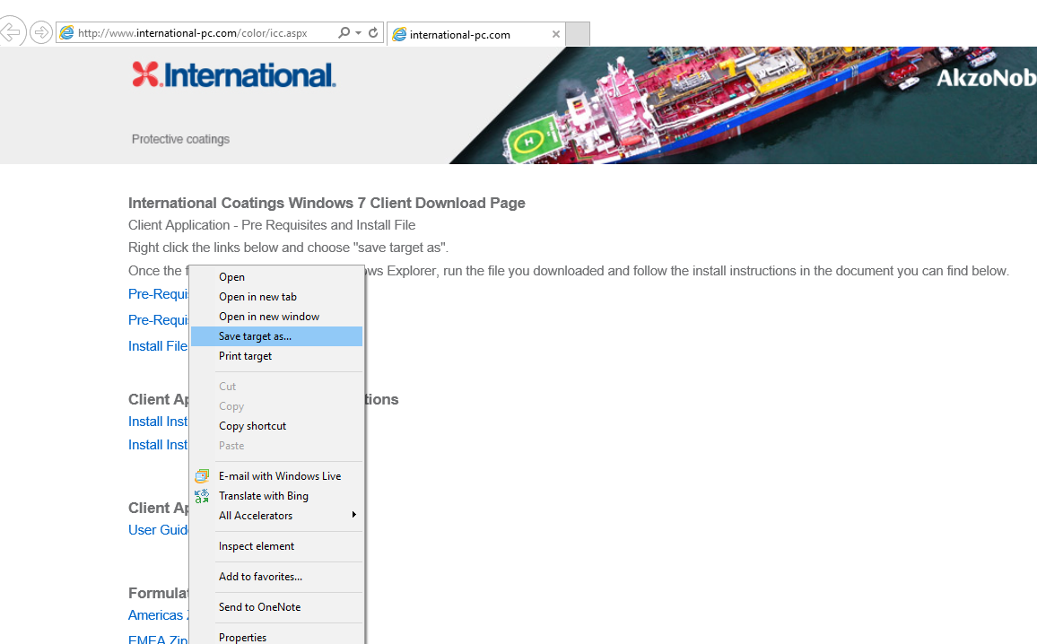
- Save into preferred location E.g. Desktop:
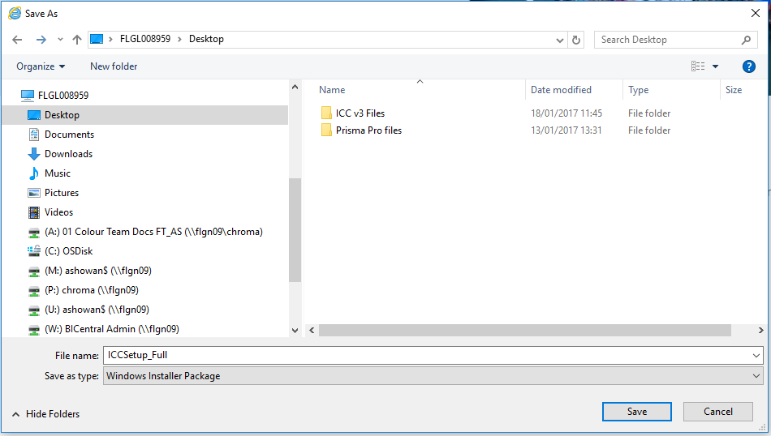

Instructions to retrieve latest regional update file

NOTE – Formulations are not interchangeable between regions. Please select the appropriate regional update file based on your location.

Users on AkzoNobel Network
- Map to a network drive (non admin user)
Files are updated daily
EMEA: \\flgn39\mpcbucoICC$\EMEA (re-connect at logon)
AP: \\flgn39\mpcbucoICC$\AP (re-connect at logon)
AMS: \\flgn39\mpcbucoICC$\AMS (re-connect at logon)
KOR: \\flgn39\mpcbucoICC$\KOR (re-connect at logon) - available March 2017
SAM: \\flgn39\mpcbucoICC$\SAM (re-connect at logon) - available March 2017

External Users not on AkzoNobel Network with Internet Access
- Open the following website link: http://www.international-pc.com/color/icc.aspx

- Download your regional update file and Save to a new folder on your ‘C’ Drive.
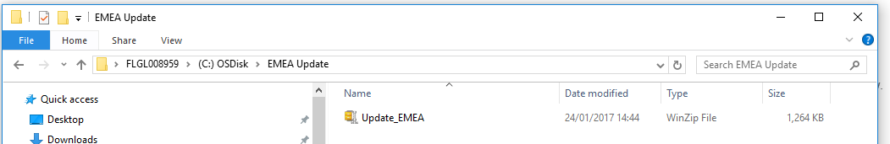

- Alternatively you can update directly from the ICC Extranet, using the following links:
EMEA - http://applications1.international-pc.com/chromaicc/emea/Update_EMEA.zip
AP - http://applications1.international-pc.com/chromaicc/ap/Update_ap.zip
AMS - http://applications1.international-pc.com/chromaicc/ams/Update_ams.zip
KOR – Not available until end of March 2017
SAM – Not available until end of March 2017.

External Users not on AkzoNobel Network with No Internet Access

- Contact the Global Colour Team for the latest regional update file via e-mail. Then store in a new folder on your C Drive

Note – the Update file is a zip file which should remain zipped.

Upgrade from ICC v2.47 to v3.0.14

Files required
- ICC V3.0.14 Install File: ICCSetup_Full
- Regional Update file (EMEA, AP, AMS, KOR or SAM)
Admin rights are required to install ICC V3.0.14 on the AkzoNobel Network

Install Steps
- Create a back-up in ICC V2.47:
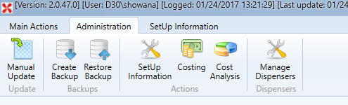
- Find Back Up file in following location:
C Drive – Program Files (x86) – Tint Centre Application – Data
e.g.
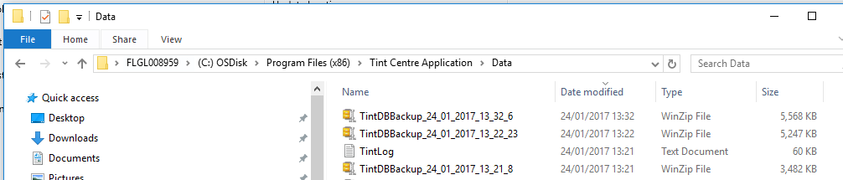

- Copy Back Up file and save to Desktop/ C Drive.
Note – this is in case an error occurs during Install and the users ICC Mix History and settings data can be restored using this Back-Up file.

- Close ICC v2.47

- Install ICC (as Admin for AkzoNobel Networked users)

- Ensure the ICC is closed

- Right select ‘ICCSetup_Full’ and select ‘Install’
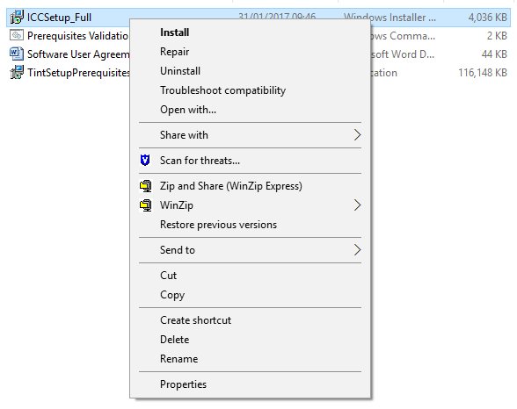
- Tint Centre Application Setup Wizard will begin:
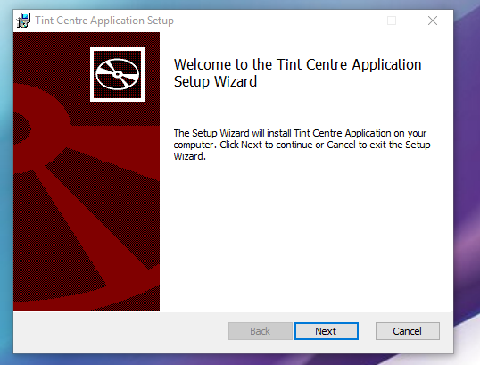
- Select Next
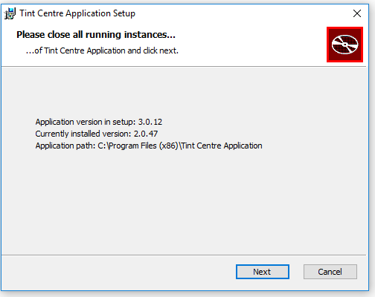
- Select Next

- Select ‘Install’:
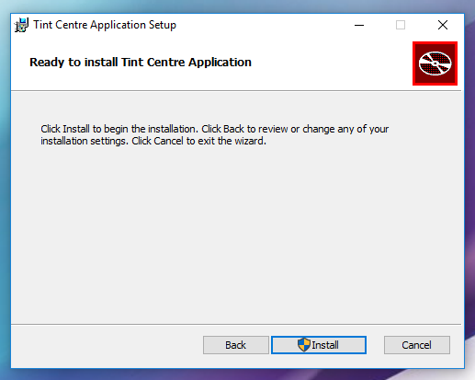
Note – prompt for Admin user to continue – select Yes

- Installation completed:
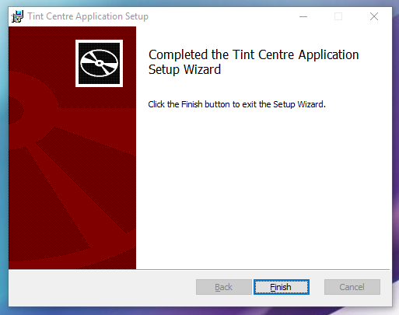
- Select ‘Finish’

- Wizard will automatically close down

- Note – If installation fails, please contact the Global Colour Team and provide the log file from error if produced.
To locate the log file please take the following path:
C Drive – Program Files (x86) – Tint Centre Application – Data – TintLog
e.g.
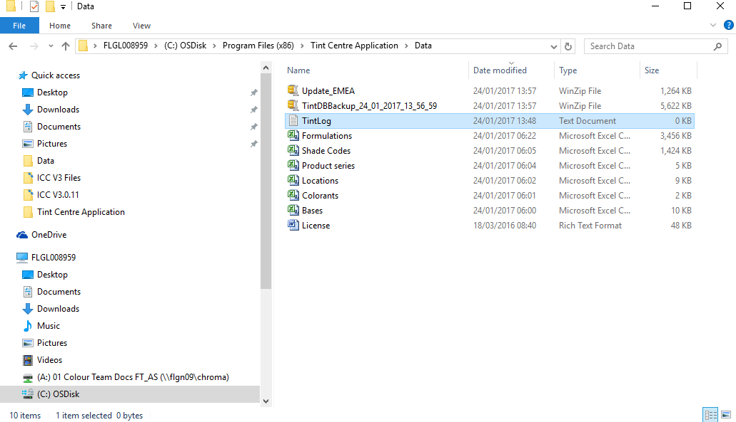
- Launch ICC V3.0.14 for the first time

- Double select ‘Tint Centre Application’ icon on desktop to open
- Confidentiality agreement opens. Select ‘I Agree’ to continue to open ICC:
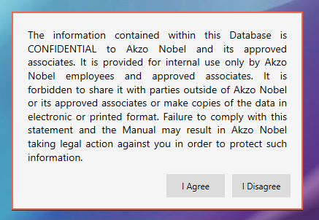
- Automatic ‘Database’ check performs, let it continue for a few moments:
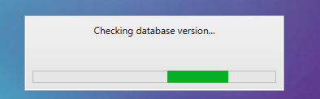
- First Time Configuration Wizard opens. To continue select ‘Next’
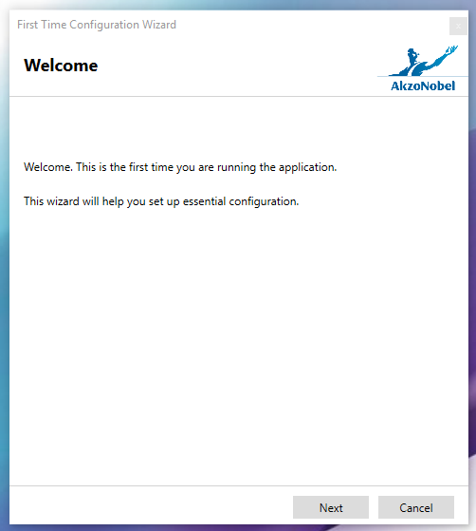
- Select your region from the ‘Region’ drop down box. E.g.
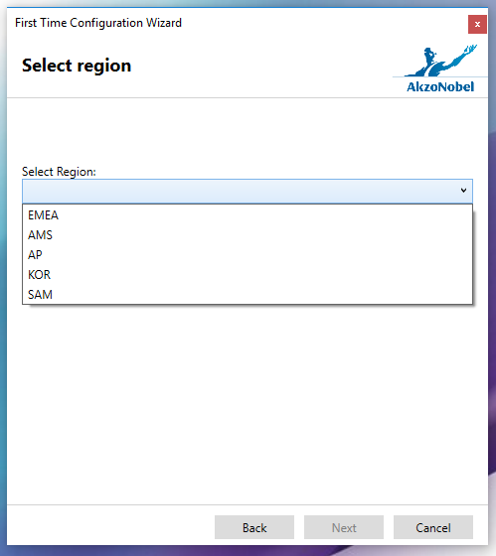
For this example, EMEA was chosen:
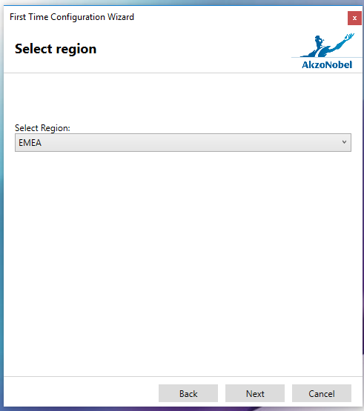
- Select ‘Next’

- Select Update Source. Choose the initial method of updating your ICC v3.0.14.
Note – for users with a good internet connection; the ICC Extranet links can now be used for updating the software.
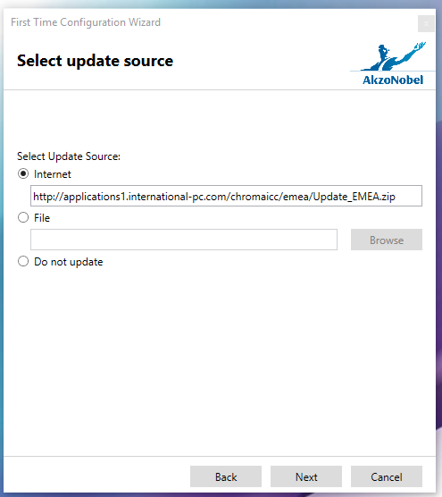
Please refer to pages 4-5 in these instructions about updating options:
- To use the chosen ICC Extranet link to update, select Next
- To use the mapped drive location for updating or a folder on your C drive; select ‘File’ and browse to your chosen location. Select Next

- Update begins:
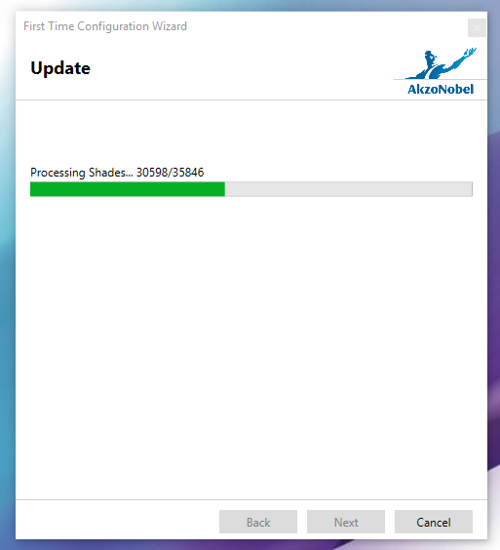
- Updated completed:
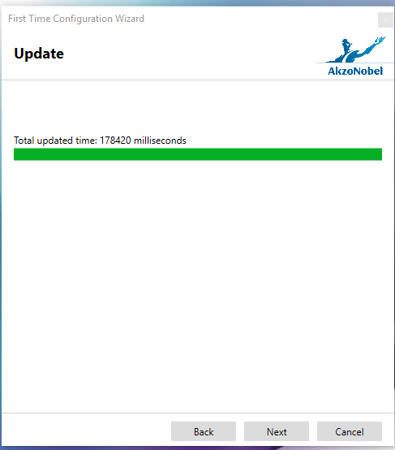
- Select Next to continue
- Select users Location from drop down list. E.g
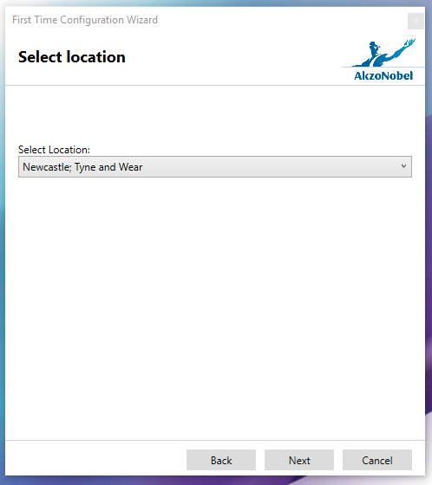
Note – if the user’s location is missing from this list, contact the Global Colour Team to provide details and a location ID will be added.

- Enter specific GUID and contact Details

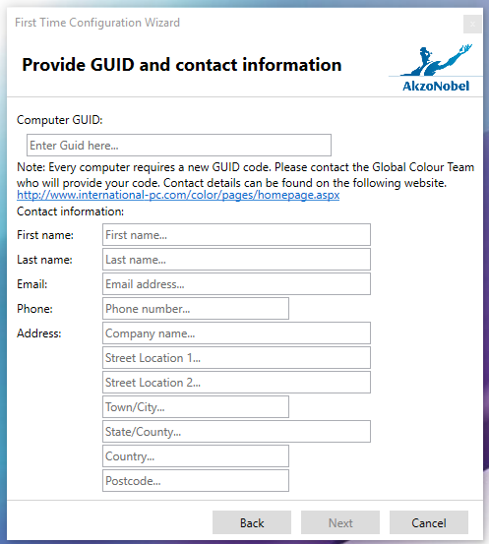

Note – you will not be able to continue past this point until you enter a valid GUID. To request your unique GUID number please contact the Global Colour Team (details in contents page). For locations where the ICC v3.0.14 will be installed on more than one computer, a valid GUID will be required for each computer.
Please include the number of computers which require a GUID, and specify if the computer has internet access in your GUID request.

- Enter in valid GUID and contact details. E.g.
Your allocated GUID should be inputted here
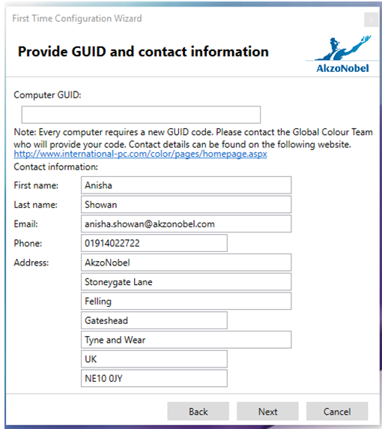
- Select Next once all details have been filled in accurately.
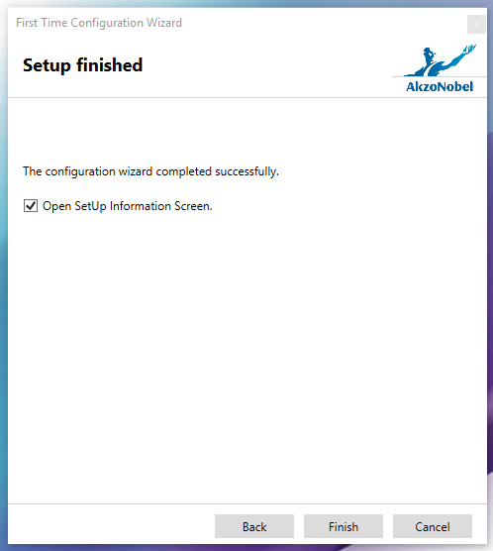
- SetUp is completed. Select Finish
- ICC V3.0.14 opens:
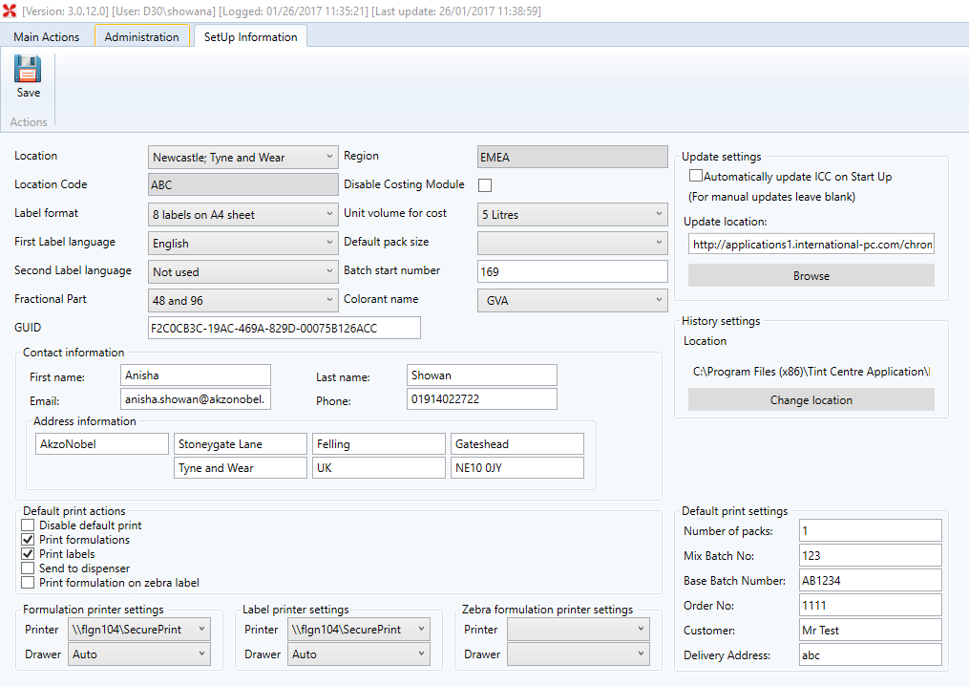
- All settings, Mix History, Production Report and Costing data should have been automatically transferred from v2.47.
- Please check through all settings to ensure they are correct. Change where necessary.
- Do not change GUID details unless otherwise agreed with the Global Colour Team.

- ICC software will update automatically each day on opening of the program. To enable automatic updates on computer start up, select the ‘Automatically Update ICC on Start Up’ box (this will only work for users who are mapped to the networked drive, or have a good internet connection using the ICC Extranet link). Save settings:
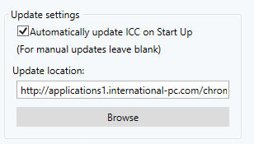
Note – If you experience any issues during the set up configuration, please contact the Global Colour Team and provide the log file from error.
To locate the log file please take the following path:
C Drive – Program Files (x86) – Tint Centre Application – Data – TintLog

Clean ICC V3.0.14 Install (New User)

Files Required:
- Pre-requisites Validation: Prerequisites Validation
- Pre-requisites Installation File: TintSetUpPrerequisites
- ICC V3.0.14 Install File: ICCSetup_Full
- Regional Update file (EMEA, AP, AMS, KOR or SAM)
Admin rights are required to install ICC V3.0.14 on the AkzoNobel Network

Install Steps
- Run Pre-Requisites Validation

- Double select ‘Prerequisites Validation’ to run validation check:
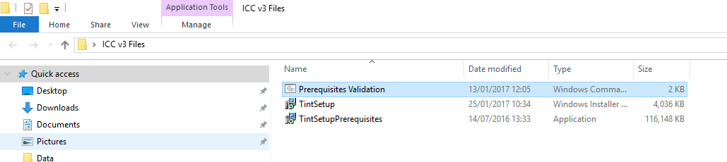
- Validation will run through:
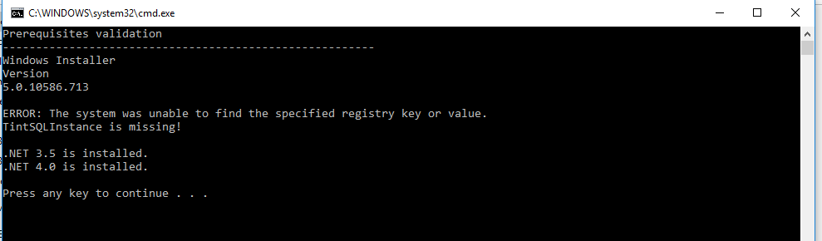
- If Validation shows that either .NET or SQL Instance is missing, you must run the Pre-Requisites installation. Follow instructions - step 2.
- If Validation shows that all .NET and SQL are installed, you can begin installing ICC V3.0.14. Follow instructions - step 3.
- To close the Validation simply select any key on keyboard or select ‘close’ in top navigation bar

- Install ICC Pre-Requisites (as Admin for AkzoNobel Networked users)

- Right select ‘TintSetupPrerequisites’ and select ‘Run as administrator’
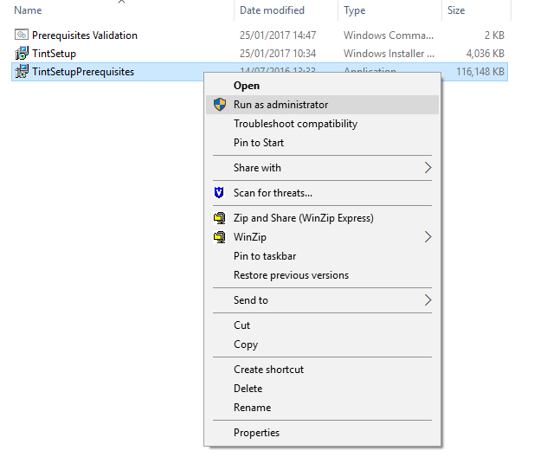
Note – prompt for Admin user to continue – select Yes

- Tint Centre Application Prerequisites Setup will begin:
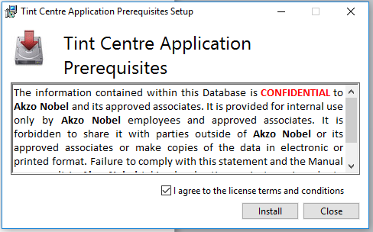
- Select ‘I agree to the licence terms and conditions’ to continue with the installation
- Select ‘Install’

- Pre-requisites begins install:
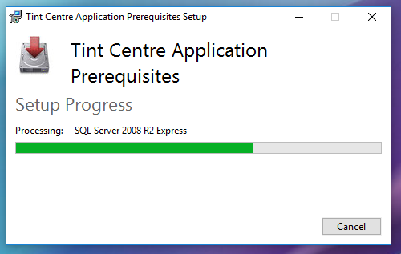
- Pre-requisites successfully installed:
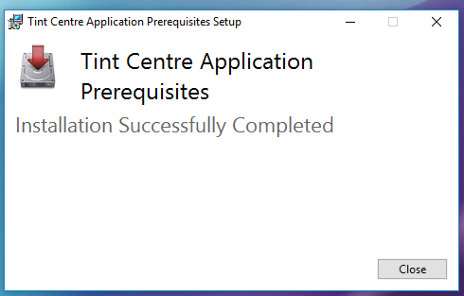
- Select ‘Close’ to finish

Note – If installation fails, please contact the Global Colour Team
- Run Pre-requisites Validation again to check installation of SQL/ .NET was successful (step 1)

- If Pre-requisites installation was successful, you should receive the following:
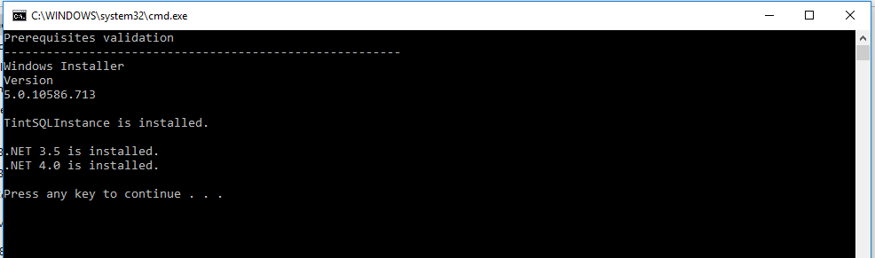
- Install ICC (as Admin for AkzoNobel Networked users)

- Right select ‘TintSetup’ and select ‘Install’
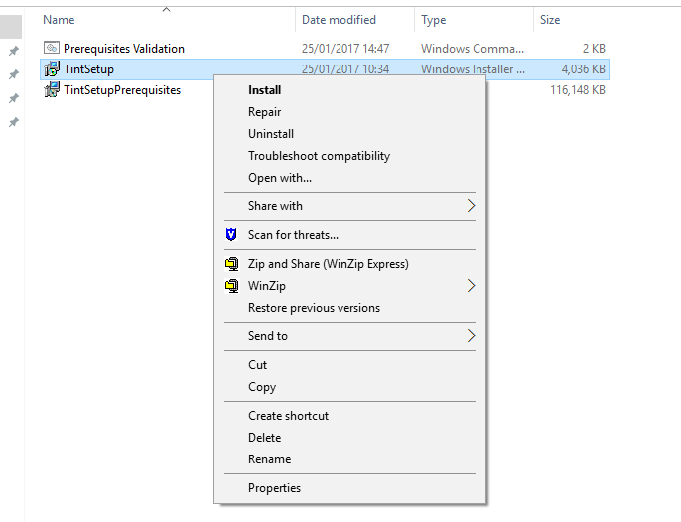
- Tint Centre Application Setup Wizard will begin:
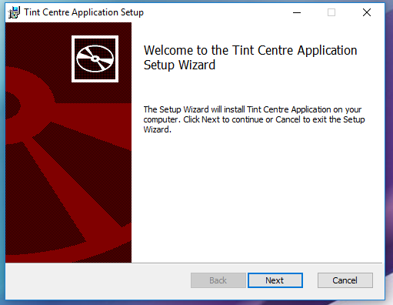

- Select Next

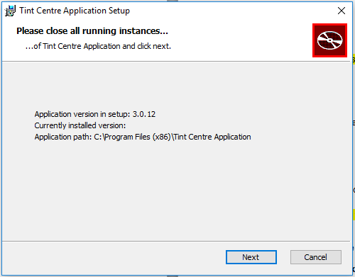
- Select Next
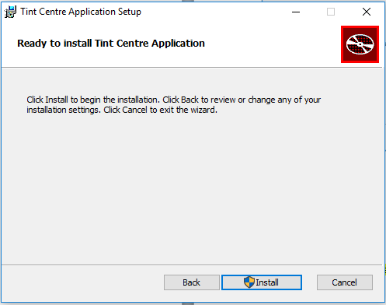

- Select ‘Install’:

Note – prompt for Admin user to continue – select Yes

- Installation completed:
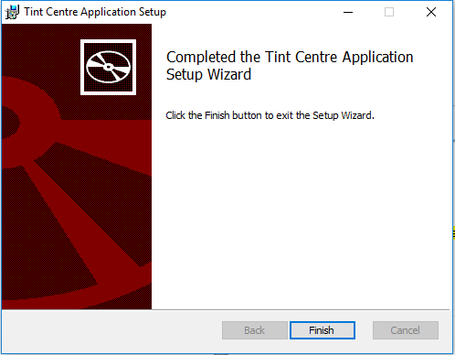
- Select ‘Finish’

- Wizard will automatically close down

- Note – If installation fails, please contact the Global Colour Team and provide the log file from error if produced.
To locate the log file please take the following path:
C Drive – Program Files (x86) – Tint Centre Application – Data – TintLog
e.g.
- Launch ICC V3.0.14 for the first time

- Double select ‘Tint Centre Application’ icon on desktop to open
- Confidentiality agreement opens. Select ‘I Agree’ to continue to open ICC:
- Automatic ‘Database’ check performs, let it continue for a few moments:
- First Time Configuration Wizard opens. To continue select ‘Next’
- Select your region from the ‘Region’ drop down box. E.g.
For this example, EMEA was chosen:
- Select ‘Next’

- Select Update Source. Choose the initial method of updating your ICC v3.0.14.
Note – for users with a good internet connection; the ICC Extranet links can now be used for updating the software.
Please refer to pages 4 and 5 in these instructions about updating options:
- To use the chosen ICC Extranet link to update, select Next
- To use the mapped drive location for updating or a folder on your C drive; select ‘File’ and browse to your chosen location. Select Next

- Update begins:
- Updated completed:
- Select Next to continue
- Select users Location from drop down list. E.g
Note – if the user’s location is missing from this list, contact the Global Colour Team to provide details and a location ID will be added.

- Enter specific GUID and contact Details

Note – you will not be able to continue past this point until you enter a valid GUID. To request your unique GUID number please contact the Global Colour Team (details in contents page). For locations where the ICC v3.0.14 will be installed on more than one computer, a valid GUID will be required for each computer.
Please include the number of computers which require a GUID, and specify if the computer has internet access in your GUID request.

- Enter in valid GUID and contact details. E.g.
Enter in allocated GUID number here:
- Select Next once all details have been filled in accurately.
- SetUp is completed. Select Finish
- ICC V3.0.14 opens:
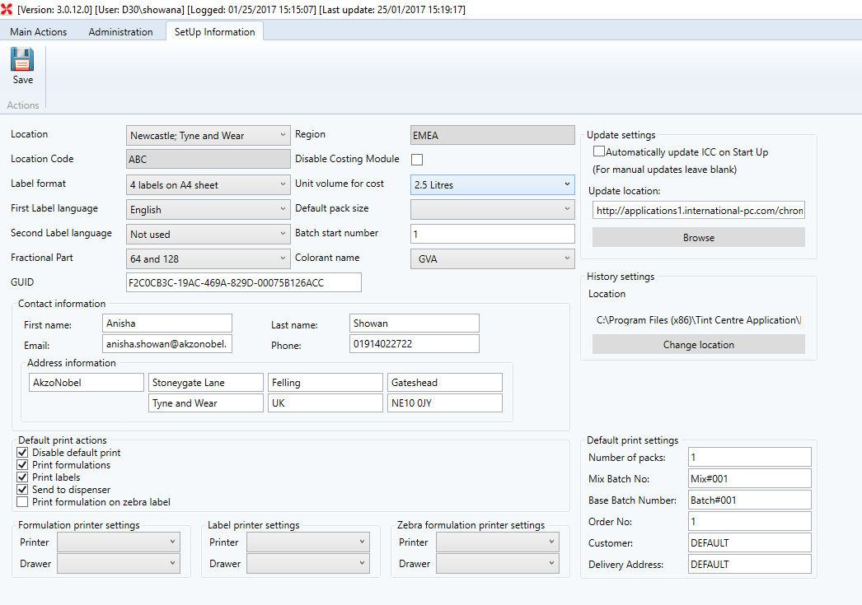
- All default settings have been automatically inputted.
- Ensure you change the settings to match your regions needs and select ‘Save’ to ensure the settings have been saved correctly.
- Do not change GUID details unless otherwise agreed with the Global Colour Team.

- ICC Software will update automatically each day on opening of the program. To enable automatic updates on computer start up, select the ‘Automatically Update ICC on Start Up’ box (this will only work for users who are mapped to the networked drive, or have a good internet connection using the ICC Extranet link). Save settings:
Note – If you experience any issues during the set up configuration, please contact the Global Colour Team and provide the log file from error.
To locate the log file please take the following path:
C Drive – Program Files (x86) – Tint Centre Application – Data – TintLog

Recommended settings for each Region

EMEA: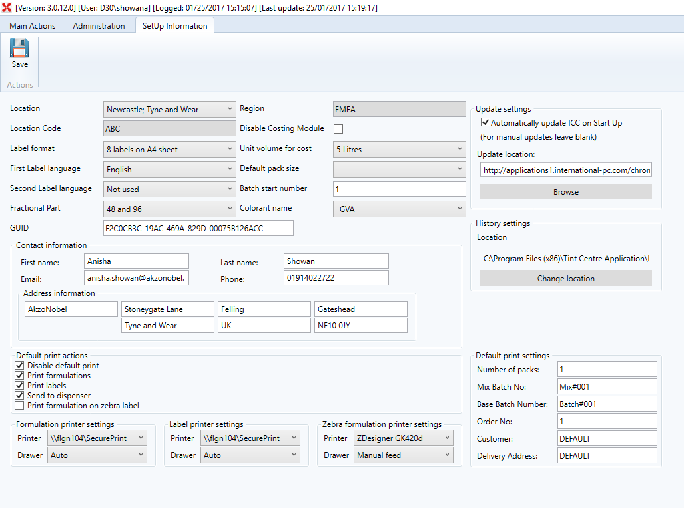

EMEA Setting | Type
Label Format | 8 Labels on A4 sheet (or Zebra or 4 labels on A4)
Second Label Language | This inserts a second language for all headings on labels. Select language as required
Fractional Part | 48 and 96
Disable Costing Module | Leave Un-ticked
Unit Volume for Cost | 5 Liters
Default Pack Size | 5 Liters and 20 Liters
Colorant Name | GVA
Update Settings | Enable Automatic Updates if access to internet  Browse to Regional Update location  If access to internet; use the ICC Extranet update links
History Settings | Set Location to:  C:\Program Files (x86)\ Tint Centre Application\ Data
GUID | The GUID should remain as is unless otherwise granted by the Global Colour Team
Contact Information | Change contact details as required
Print Labels Setting | Printer/ Drawer – this will pick up from PC’s standard settings. Select appropriate printer for labels
Print Formulation Setting | Printer/ Drawer – this will pick up from PC’s standard settings. Select appropriate printer for formulations
Zebra Formulation printer settings | Only for use with Zebra printers. Pick the ZDesigner GK420d printer and Manual Feed Drawer. This will print the formulation onto a zebra label.
Default Print Actions | Disable Default Print – check box  Print Formulations  Print Labels  Send to Dispenser  (All default settings therefore check the boxes depending on use)
Default Print Settings | Leave blank if not used  Otherwise enter in some generic data:  Number of Packs: 1  Mix Batch No: 123  Base Batch No: AB1234  Order No: 111  Customer: Mr Test  Delivery Address: ABC
THEN SAVE!

AP: 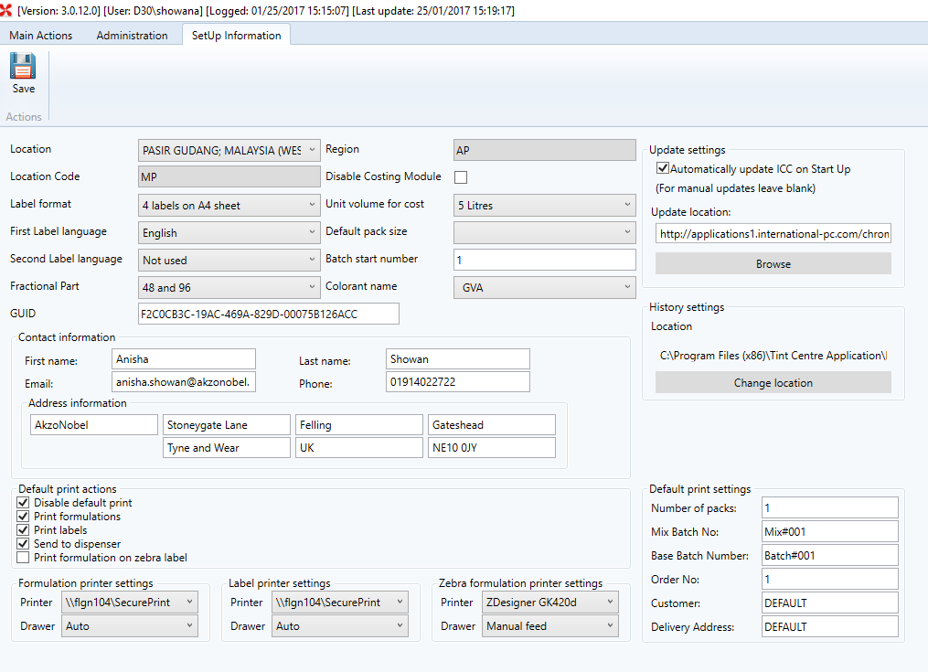

AP Setting | Type
Label Format | 4 Labels on A4 sheet (or Zebra or 8 labels on A4)
Second Label Language | This inserts a second language for all headings on labels. Select language as required
Fractional Part | 48 and 96
Disable Costing Module | Leave Un-ticked
Unit Volume for Cost | 5 Liters
Default Pack Size | 5 Liters and 20 Liters
Colorant Name | GVA
Update Settings | Enable Automatic Updates if access to internet  Browse to Regional Update location  If access to internet; use the ICC Extranet update links
History Settings | Set Location to:  C:\Program Files (x86)\ Tint Centre Application\ Data
GUID | The GUID should remain as is unless otherwise granted by the Global Colour Team
Contact Information | Change contact details as required
Print Labels Setting | Printer/ Drawer – this will pick up from PC’s standard settings. Select appropriate printer for labels
Print Formulation Setting | Printer/ Drawer – this will pick up from PC’s standard settings. Select appropriate printer for formulations
Zebra Formulation Printer Settings | Only for use with Zebra printers. Pick the ZDesigner GK420d printer and Manual Feed Drawer. This will print the formulation onto a zebra label.
Default Print Actions | Disable Default Print – check box  Print Formulations  Print Labels  Send to Dispenser  (All default settings therefore check the boxes depending on use)
Default Print Settings | Leave blank if not used  Otherwise enter in some generic data:  Number of Packs: 1  Mix Batch No: 123  Base Batch No: AB1234  Order No: 111  Customer: Mr Test  Delivery Address: ABC
THEN SAVE!

AMS:

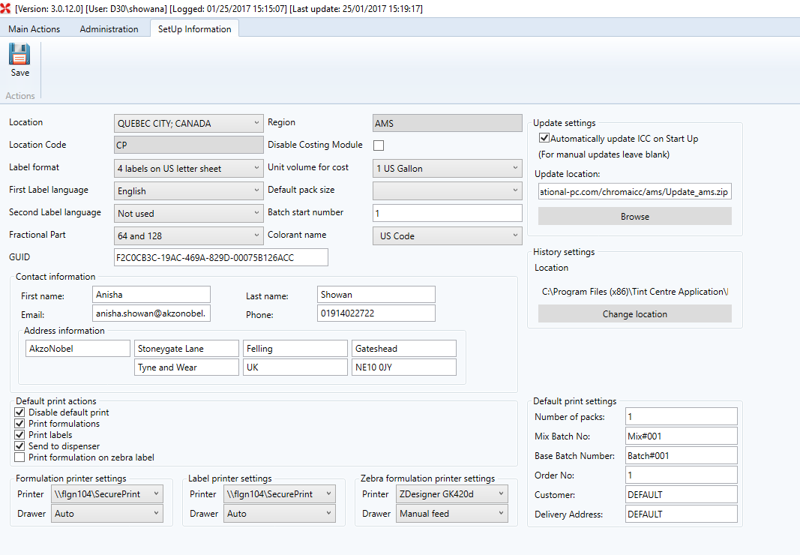

AMS Setting | Type
Label Format | 4 labels on US Letter sheet (or Zebra)
Second Label Language | This inserts a second language for all headings on labels. Select language as required
Fractional Part | 64 and 128
Disable Costing Module | Leave Un-ticked
Unit Volume for Cost | 1 US Gallon
Default Pack Size | 1 Us Gallon and 5 US Gallon
Colorant Name | US Code
Update Settings | Enable Automatic Updates if access to internet  Browse to Regional Update location  If access to internet; use the ICC Extranet update links
History Settings | Set Location to:  C:\Program Files (x86)\ Tint Centre Application\ Data
GUID | The GUID should remain as is unless otherwise granted by the Global Colour Team
Contact Information | Change contact details as required
Print Labels Setting | Printer/ Drawer – this will pick up from PC’s standard settings. Select appropriate printer for labels
Print Formulation Setting | Printer/ Drawer – this will pick up from PC’s standard settings. Select appropriate printer for formulations
Zebra Formulation Settings | Only for use with Zebra printers. Pick the ZDesigner GK420d printer and Manual Feed Drawer. This will print the formulation onto a zebra label.
Default Print Actions | Disable Default Print – check box  Print Formulations  Print Labels  Send to Dispenser  (All default settings therefore check the boxes depending on use)
Default Print Settings | Leave blank if not used  Otherwise enter in some generic data:  Number of Packs: 1  Mix Batch No: 123  Base Batch No: AB1234  Order No: 111  Customer: Mr Test  Delivery Address: ABC
THEN SAVE!

SAM:
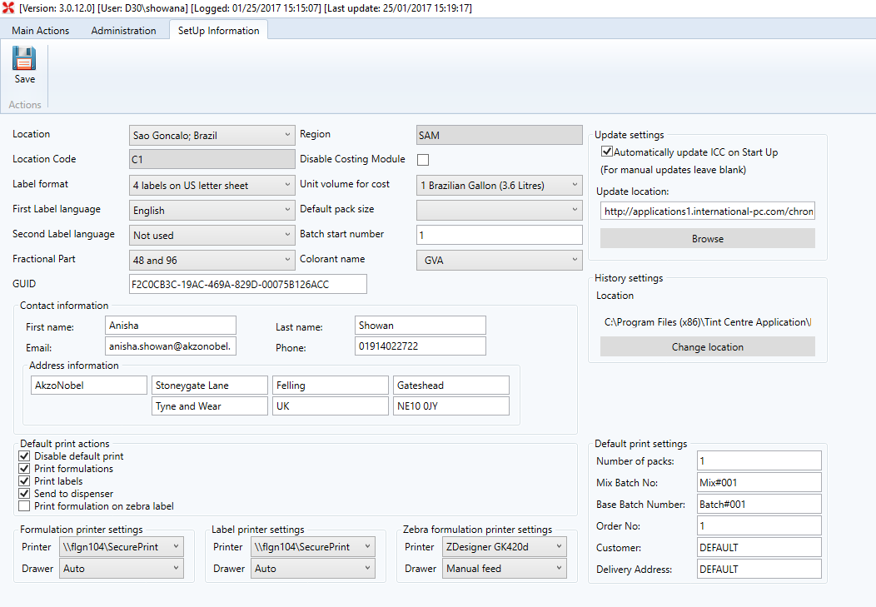

SAM Setting | Type
Label Format | 4 labels on US Letter sheet (or Zebra)
Second Label Language | This inserts a second language for all headings on labels. Select language as required
Fractional Part | 48 and 96
Disable Costing Module | Leave Un-ticked
Unit Volume for Cost | 1 Brazilian Gallon
Default Pack Size | 1 Brazilian Gallon and 20 Liters
Colorant Name | GVA
Update Settings | Enable Automatic Updates if access to internet  Browse to Regional Update location  If access to internet; use the ICC Extranet update links
History Settings | Set Location to:  C:\Program Files (x86)\ Tint Centre Application\ Data
GUID | The GUID should remain as is unless otherwise granted by the Global Colour Team
Contact Information | Change contact details as required
Print Labels Setting | Printer/ Drawer – this will pick up from PC’s standard settings. Select appropriate printer for labels
Print Formulation Setting | Printer/ Drawer – this will pick up from PC’s standard settings. Select appropriate printer for formulations
Zebra Formulation Settings | Only for use with Zebra printers. Pick the ZDesigner GK420d printer and Manual Feed Drawer. This will print the formulation onto a zebra label.
Default Print Actions | Disable Default Print – check box  Print Formulations  Print Labels  Send to Dispenser  (All default settings therefore check the boxes depending on use)
Default Print Settings | Leave blank if not used  Otherwise enter in some generic data:  Number of Packs: 1  Mix Batch No: 123  Base Batch No: AB1234  Order No: 111  Customer: Mr Test  Delivery Address: ABC
THEN SAVE!

KOR:

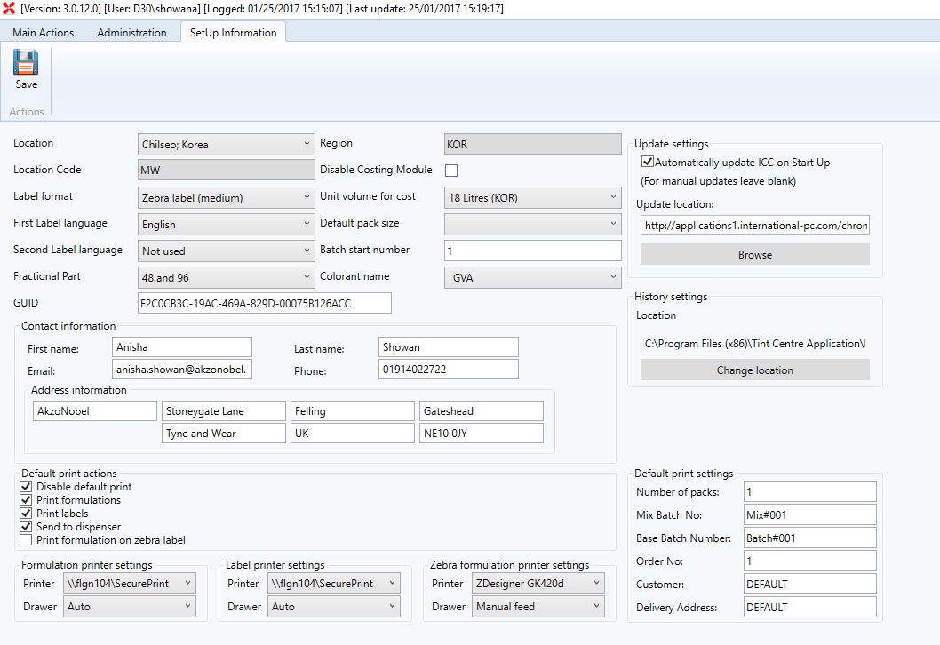

KOR Setting | Type
Label Format | Medium Zebra Label
Second Label Language | This inserts a second language for all headings on labels. Select language as required
Fractional Part | 48 and 96
Disable Costing Module | Leave Un-ticked
Unit Volume for Cost | 18 Litres (KOR)
Default Pack Size | 18 Litres (KOR)
Colorant Name | GVA
Update Settings | Enable Automatic Updates if access to internet  Browse to Regional Update location  If access to internet; use the ICC Extranet update links
History Settings | Set Location to:  C:\Program Files (x86)\ Tint Centre Application\ Data
GUID | The GUID should remain as is unless otherwise granted by the Global Colour Team
Contact Information | Change contact details as required
Print Labels Setting | Printer/ Drawer – this will pick up from PC’s standard settings. Select appropriate printer for labels
Print Formulation Setting | Printer/ Drawer – this will pick up from PC’s standard settings. Select appropriate printer for formulations
Zebra Formulation Settings | Only for use with Zebra printers. Pick the ZDesigner GK420d printer and Manual Feed Drawer. This will print the formulation onto a zebra label.
Default Print Actions | Disable Default Print – check box  Print Formulations  Print Labels  Send to Dispenser  (All default settings therefore check the boxes depending on use)
Default Print Settings | Leave blank if not used  Otherwise enter in some generic data:  Number of Packs: 1  Mix Batch No: 123  Base Batch No: AB1234  Order No: 111  Customer: Mr Test  Delivery Address: ABC
THEN SAVE!

How to Map to a Network Drive (for Akzo Network Users)

- To map a network drive you will need to do the following.

- Open Windows Explorer.

- Select Tools and then select Map Network Drive
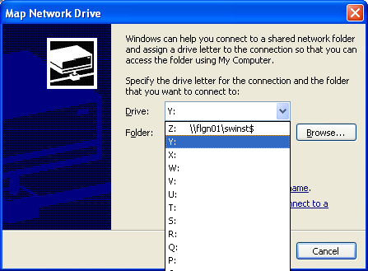

- The system will automatically select a drive letter for you, but if you wish to change it click on the drop down arrow next to the Drive selection and select an appropriate drive letter.

- In the Folder box, specify the name of network share.

- Select the appropriate regional network share listed on page 39.
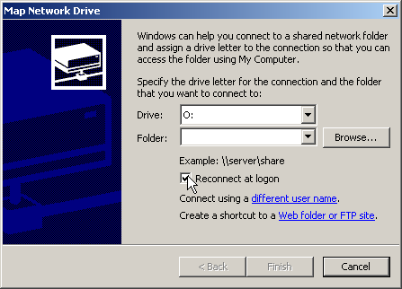

- Make sure that the Reconnect at logon box is checked and click on Finish.

- This will then add the mapped drive in Windows Explorer, and should be accessible immediately (assuming you have the necessary security permissions). If you don’t have permissions to access the share you should contact the global colour team.

Mapped Drive Locations:

Files are updated daily
EMEA: \\flgn39\mpcbucoICC$\EMEA (re-connect at logon)
AP: \\flgn39\mpcbucoICC$\AP (re-connect at logon)
AMS: \\flgn39\mpcbucoICC$\AMS (re-connect at logon)
KOR: \\flgn39\mpcbucoICC$\KOR (re-connect at logon) - available March 2017
SAM: \\flgn39\mpcbucoICC$\SAM (re-connect at logon) - available March 2017

Example of mapped drive to \\FLGN39\mpcbucoICC$\EMEA

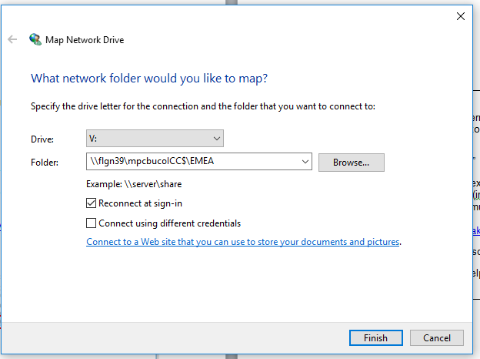

E.g. Mapped folder:

How to retrieve a Log File

Retrieving Log Files | - When an error occurs in the Client Software, often there will be a warning message to users to:  “Refer to Log File”  - This is a text file which includes text to notify the user where an error has occurred. (in a string of text and numbers).  - The user must retrieve this log file and send it to:  anisha.showan@akzonobel.com or francesca.trobec@akzonobel.com  (Include some description of the error you received in the email).  - This will help to uncover why or how the error occurred.
How to find the Log File  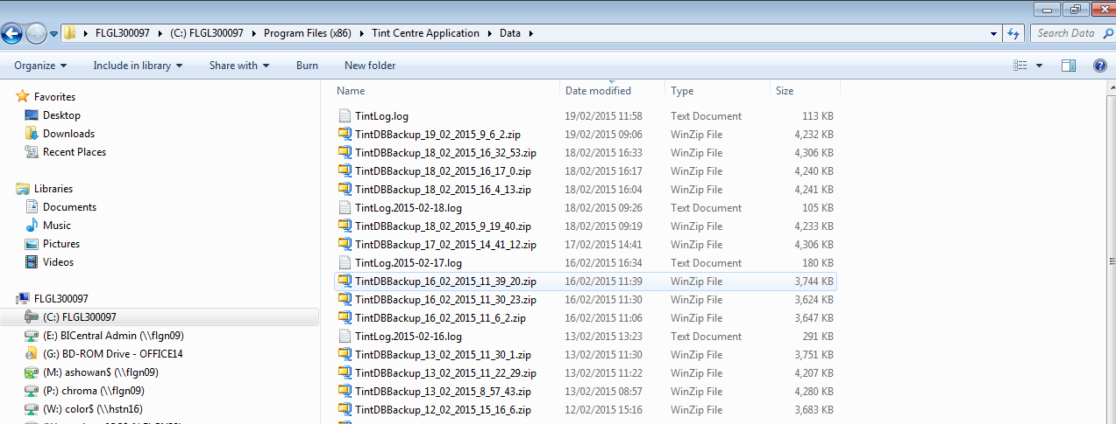 | - All log files are stored in the ‘Data’ folder (where Back-Up files are stored).  - File Destination:  ‘C’ Drive – Program Files (x86) – Data  - The log file will be in the name of ‘Tint.log’ as an example.  E.g. With this example, I have highlight where a log file has been automatically stored by the Client software:  - This is the ‘Log-File’ the system will be referring to.  - Therefore, send the most recent file to the support team if you have an error. We will try our best to resolve the issue.

